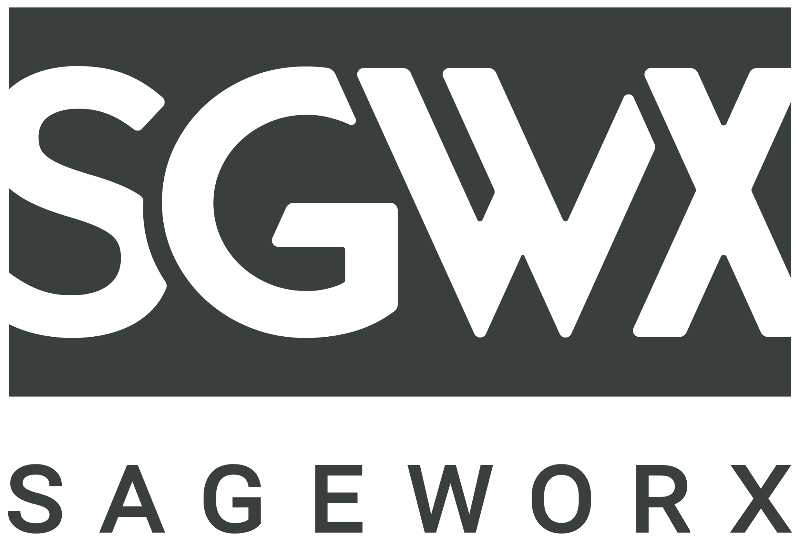
PROJECT BRIEF

Internal notes in italics: This is a Living Brief, with Client’s specific requests captured by the project lead following the initial RFP → used to activate the team accurately + comprehensively at the outset, and continually updated with any relevant, clarifying information from follow up discussions with Client → so each time, in each review, we can return to the project goals to confirm we hit them.

CLIENT:

OVERVIEW / BACKGROUND: what is the situation?
What is the business context, the competitive landscape, the industry category? What products, talent or resources are required? Is there client-provided inspiration? Any other notes on context, and why they chose you for this assignment?

THE ASSIGNMENT: what are you asking us to create, and why?

WHO ARE WE TALKING TO?
What do we know about them? Which segment are we trying to reach, and what is their journey? Tell us about the person, not just the demographics. What is their perception of you? What problems are we helping them solve?

OBJECTIVES: what must the assignment achieve?
What do we want the work to accomplish? Bottom line goals, prioritized in order of importance. KPIs, yes -- but most importantly, what change in behavior or action do you want to see from the audience?

Client’s goals

- …
- …
- …

KEY COMMUNICATION: what must we communicate?
What is the prioritized messaging? If only one message survives, which one? Is there a campaign slogan we are building from? If the audience remembers one thing, what should it be?

WHAT DO WE WANT THE AUDIENCE TO DO?
Know something, buy, share, go somewhere? If the initiative succeeds, how do we want people to think, feel and act? What do we want them to do differently as a result of seeing, using or visiting this work? If you have a specific call to action in mind, list it here.

MANDATORIES: what and who must be included?
A new logo or content imagery to feature? Campaign assets, social integration, event partnerships, promotions, retail partners? Anything required by legal, regulatory or contractual terms?

CREATIVE CONSIDERATIONS: what should we keep top of mind?
Strategically and creatively, what matters most? What brand style, voice guidelines and usage rules apply? What has performed best historically? Is there a look of success to match, or a new positioning to mirror?

TECHNICAL CONSIDERATIONS: what does the build require?
Specific platforms? Responsive design, mobile and tablet versions? Is there a CRM or an existing system this has to integrate with?

KNOWN CHANNELS / TACTICS: where will this live?
Where will the messaging and content be consumed? Is there a strategy for each channel? What are your highest-performing platforms?

TIMING: when does this launch?
Is it tied to an external deadline, event or product launch? List locations, cities or countries, and rough dates if launches are phased. What is the distribution plan?

BUDGET: what are we working with?
If an exact budget is not known, what is the broad range we should target?

DELIVERABLES (if known): what exactly are we making?
What specific things will we need to create, and in what format?

HOW WILL WE BE MEASURED?
Which KPIs are the priorities? What evidence will we look at, and when, to know whether the work did its job?

RESOURCES: who is doing the work?
Partners listed, and your resources.

Resource / Partner | Role / Responsibility | Notes | Hours Estimated

